Some plain text (Size 12)

**Text With Bold**

*Italic Text*

Underline text

~~Delete Text~~

***Bold and Italic***

Smaller (size 10)

Smaller and Underline

1. numbered list with underline
2. ~~numbered list 2 with delete~~
3. ***numbered list 3 with bold and Italic***
4. smaller numbered list 4
5. **smaller and bold numbered list 5**

* Bullet list 1
* **Bullet list 2 with bold**
* ***Bullet list 3 with bold and italic***
* [X]CheckList 1
* [ ]**CheckList 2 bold**
* [ ]***CheckList 3 bold and italic***

|  |  |  |
| --- | --- | --- |
| Table (1, 1) | Table(1, 2) | Table(1, 3) |
|  | ~~Table(2, 2) underline and delete~~ |  |
| **Table(3, 1) Bold** | ***Table(3, 2) Bold and Italic*** | **Table(3, 3) small and Bold** |

Image:

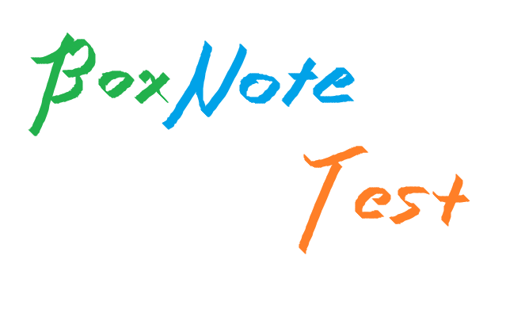

Red Colored

**Red With Bold**

**Highlight with bold purple**

Link: <https://github.com/>

Annotation

# Heading 1

## Heading 2

### Heading 3

Body

file link

codeblock

import json  
print("Hello")

⚠️Callout!

End

BlockQuote

multi-line

Alignment

Left

Center

Right

Justify the long string with alignment **“Left“**, this should be a little bit different from left alignment, keep an eye on this differnece - the side should be aligned. This paragraph is **left-aligned**.

Justify the long string with alignment **“Justify“**, this should be a little bit different from left alignment, keep an eye on this differnece - the side should be aligned. This paragraph is **justify-aligned**.